**Database Project Report**

**Project Name:** Flight Management System

**Group Members:**

Umer Shaikh (cs152009)

Fatima Kaleem (cs152038)

Kumail Abbas (cs152021)

**ER Diagram**

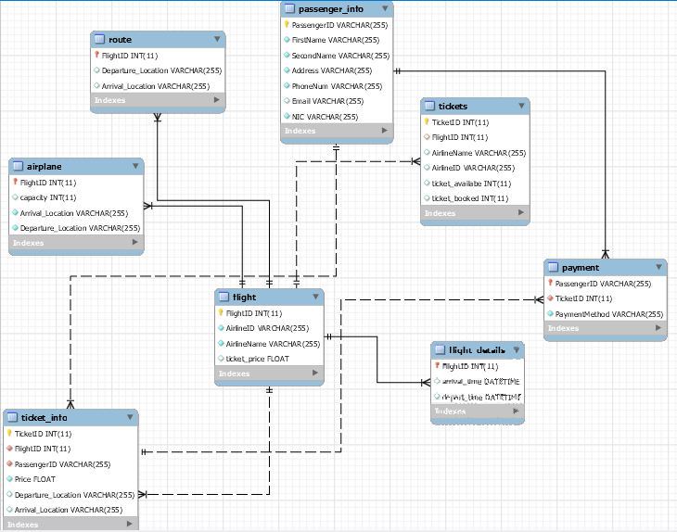

**Introduction**

Application which is made using visual C# and mysql as database. It can be used for reservation of tickets and manage their scheduled flights.

**Scope of the project**

This Project can be used to manage the Tickets , passenger’s info , Airplanes , Scheduled Flights, Arrival Location and time of any Airplane , Departure Location and time of any Airplane, Airline Companies and the payment info about the purchased tickets.

**Description of the project**

This project is based on “Flight Management System” to manage the Tickets , passenger’s info , Airplanes , Scheduled Flights, Arrival Location and time of any Airplane , Departure Location and time of any Airplane, Airline Companies and the payment info about the purchased tickets.

There will be 4 buttons on the home page

1. Booking
2. Update
3. View
4. Exit

If **Booking** will be selected , then it will open new form where it will ask for information from customer. Such that destination, then Let user select appropriate flight according to suitable time of flight. Then on the next page, it will ask for personal information of user (name,Phone Num,NIC etc) and then book his/her ticket in that flight.

If **Update** will be selected , then it will prompt that where you want to update . This function will be used if we want to make any correction or updation in our database such as passenger’s info.

If **View** will be selected , then it will prompt that what you want to view . This function will be able to view information of any passenger , Scheduled Flights , Tickets available in any flight , Airplanes available and any other information regarding to Airplanes/Flights or Passenger.

If **Exit** will be selected, then it will simply close the application an Exit.

**Snapshots**

